Amanda Travitzky

Geog 678 Lab 5 Deliverables

Links to Leaflet Tutorials:

<file:///C:/Users/Travitzky/Desktop/678%20geog/678-lab5%20tutorial/leaflet_tutorial_3.html>

<file:///C:/Users/Travitzky/Desktop/678%20geog/678-lab5%20tutorial/leaflet_tutorial_2.html>

<file:///C:/Users/Travitzky/Desktop/678%20geog/678-lab5%20tutorial/leaflet_tutorial_1.html>

<file:///C:/Users/Travitzky/Desktop/678%20geog/lab5/AT_First_Custom_Map.html>

Leeaflet tutorial 1 screenshots:

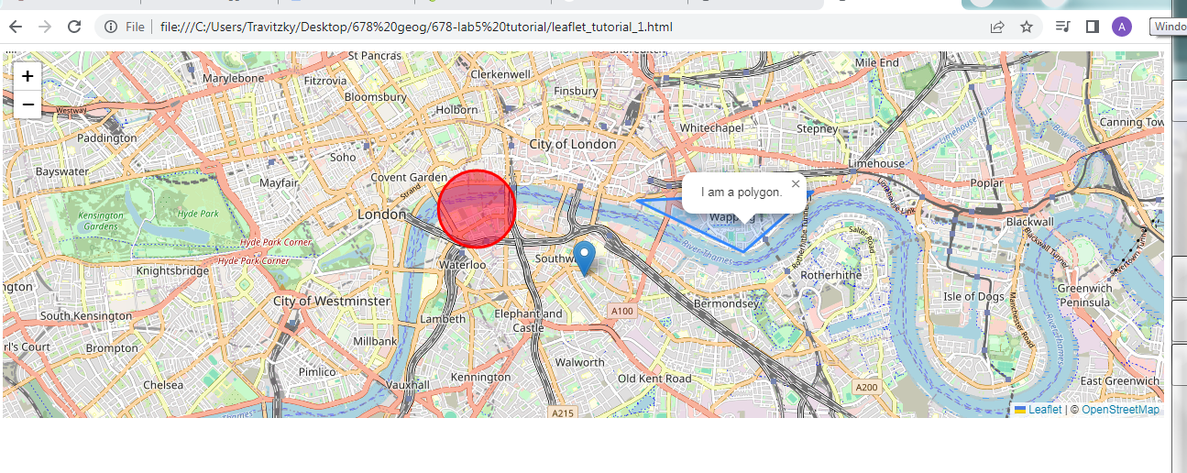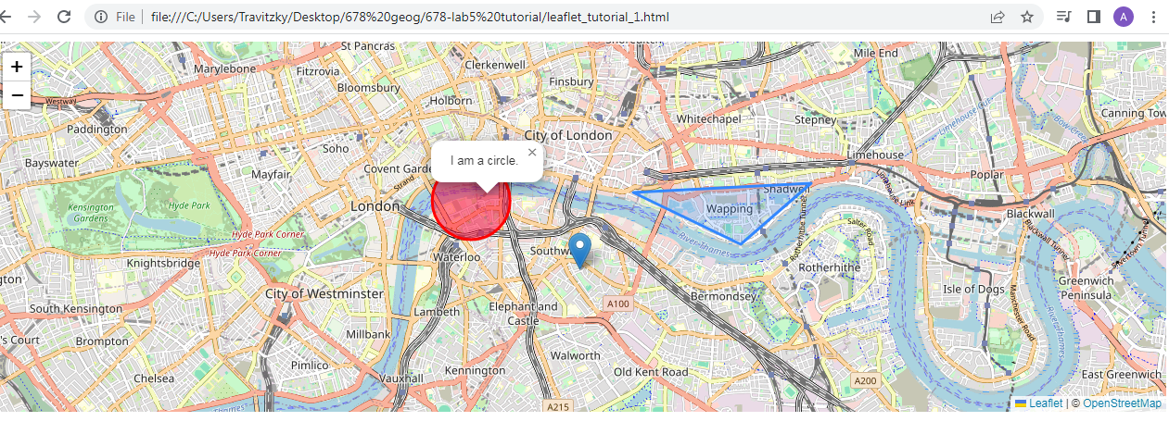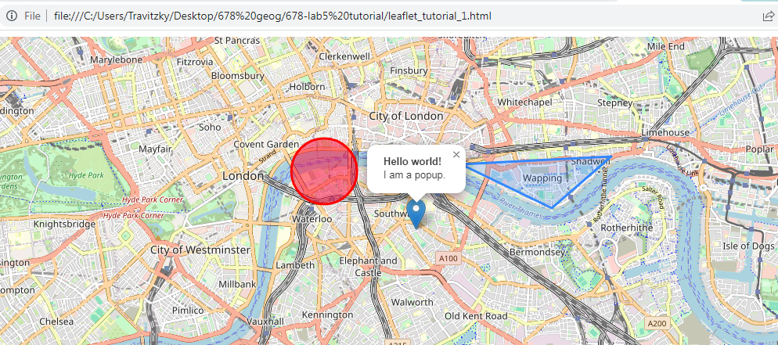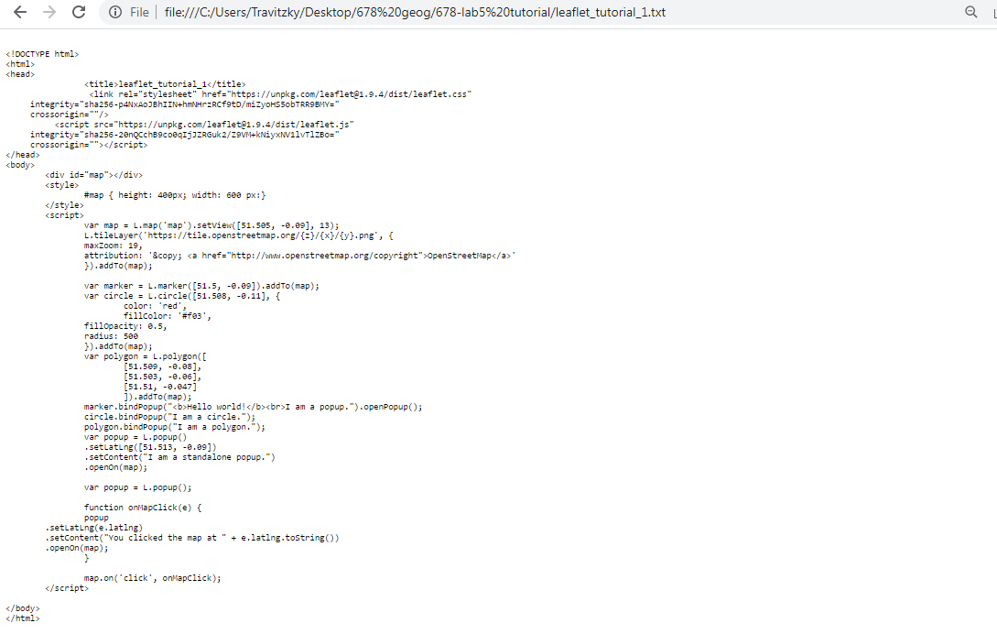

Leaflet tutorial 2 screenshots: 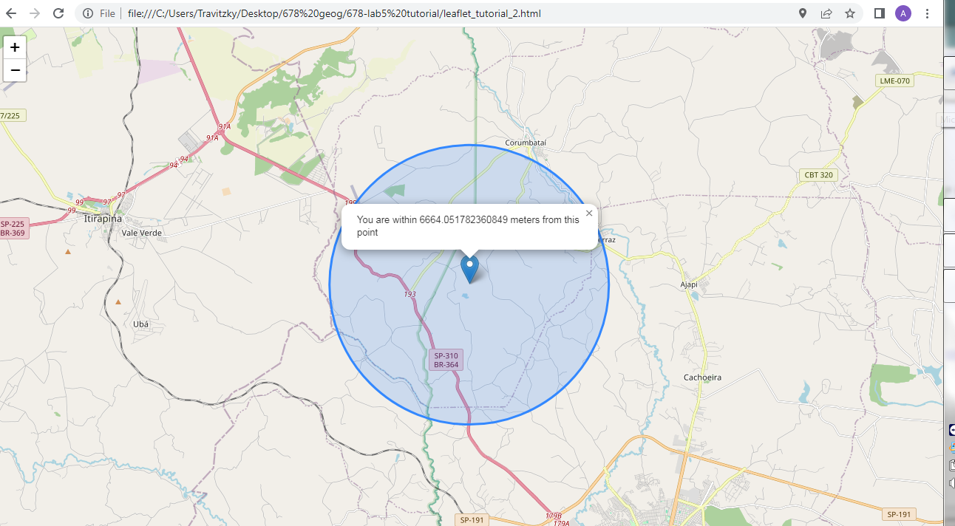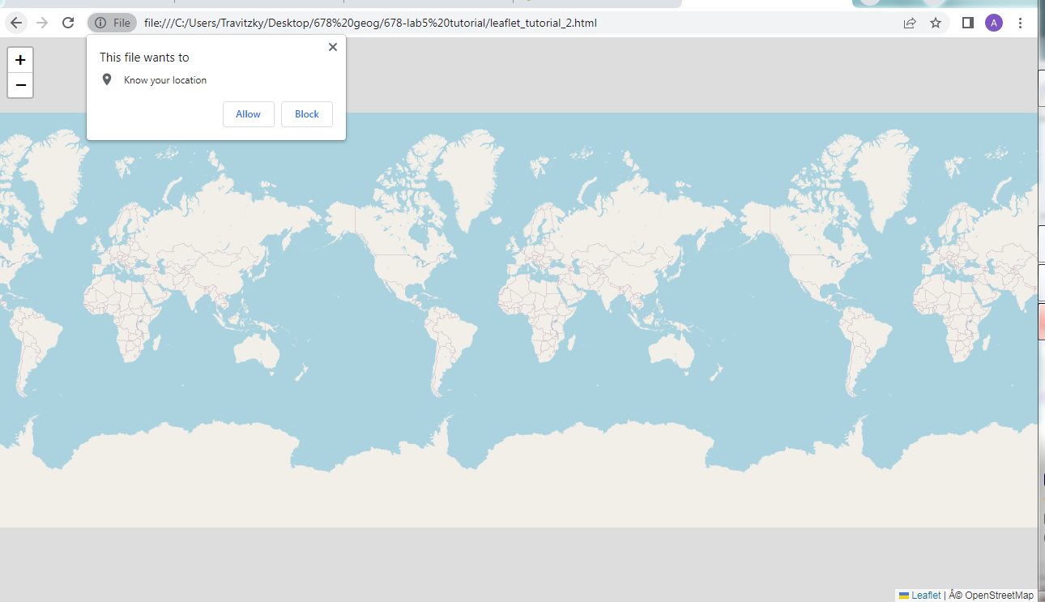

My custon map

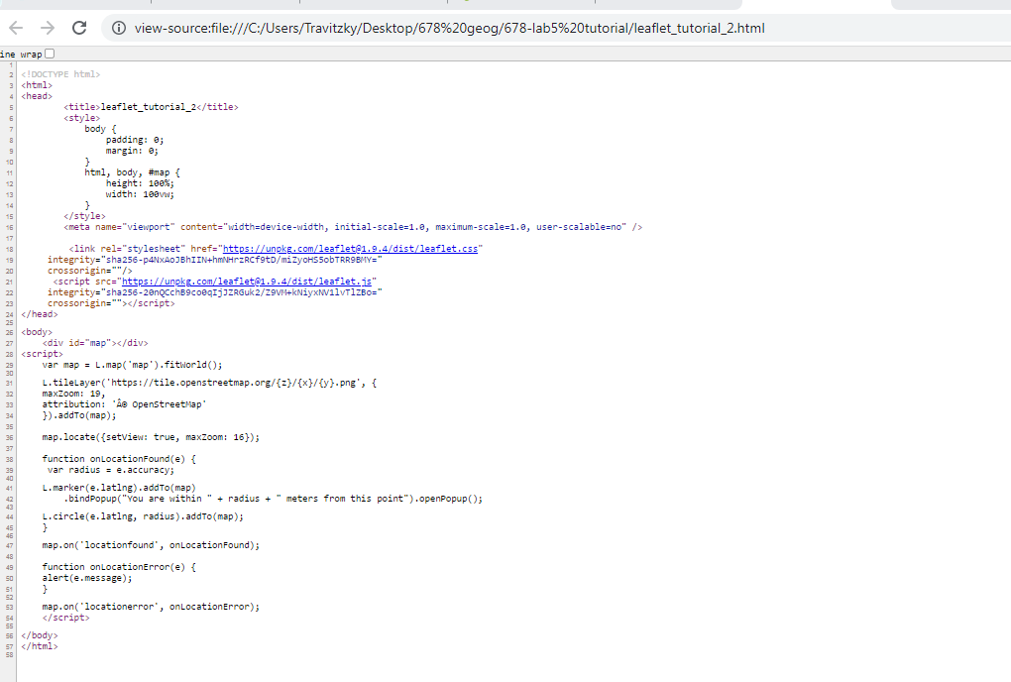

Leaflet tutorial 3 screenshots:

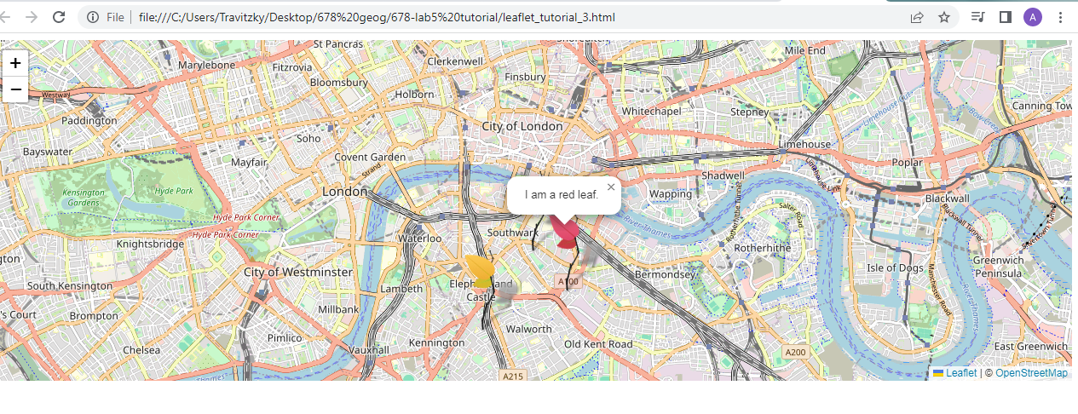

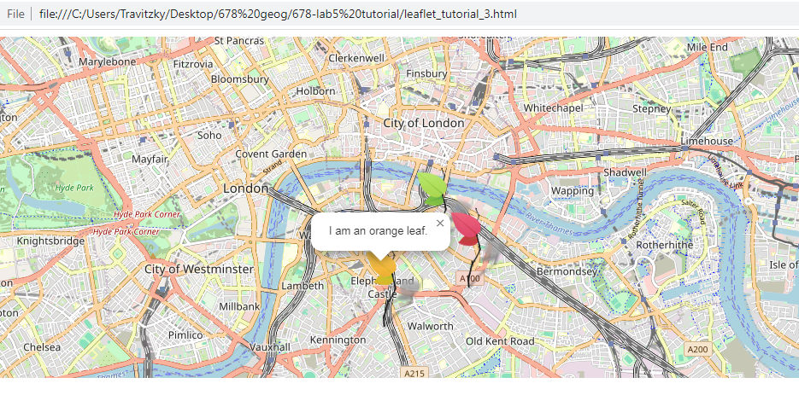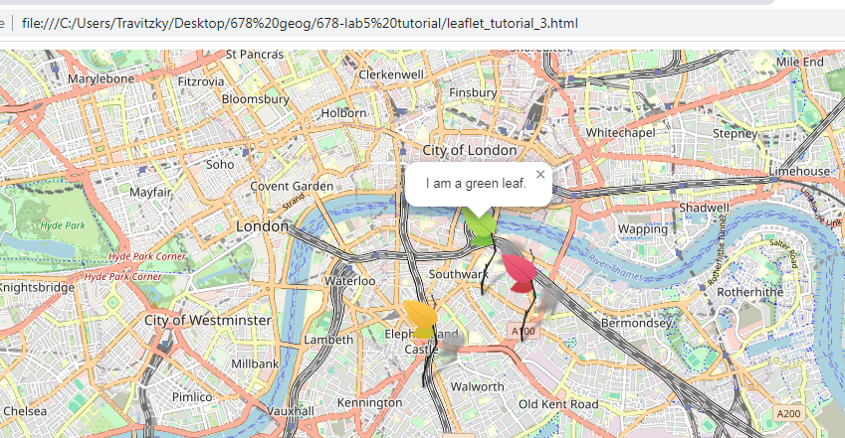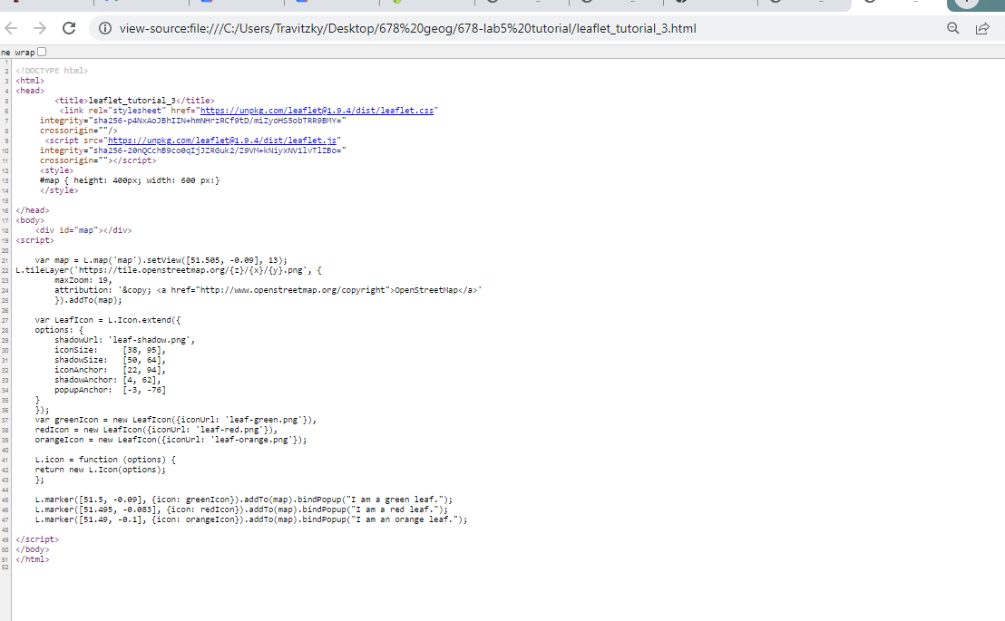

My custom map:

